Competitive Shooters of Lake Norman USPSA February 13th, 2026
COURSE DESIGNER: Rocky Perillo

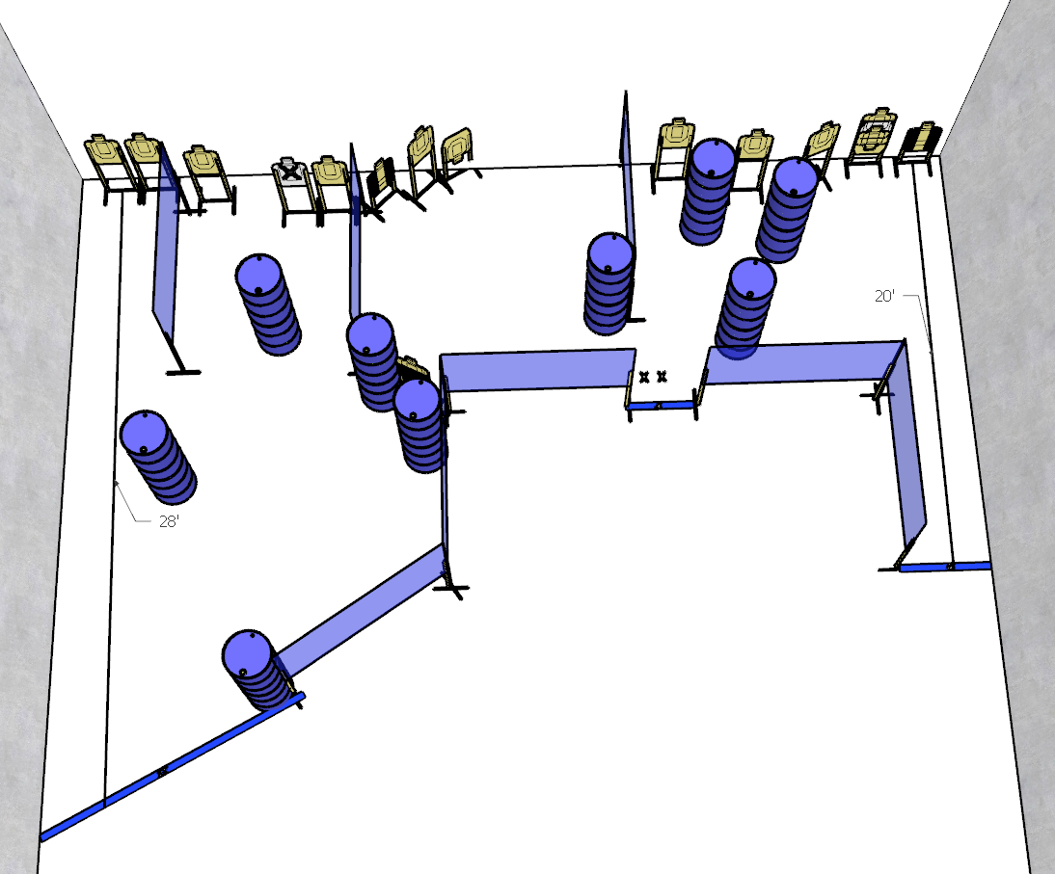

Stage 1 – You’ve stolen a pizza my heart 🍕❤️
28 rounds, 140 points, Comstock
There are 14 cardboard targets with some no-shoots.
Start position is both Feet on XXs
Handgun is loaded holstered with wrists below belt.
PCC is loaded and held with both hands and stock touching belt.
On the audible start signal, engage targets from within the shooting area.
Stage 3 – You’re the peanut butter to my jelly
30 rounds, 150 points, Comstock
There are 15 cardboard targets with some no-shoots.
Start position anywhere inside the shooting area
Handgun is loaded and holstered with wrists below belt.
PCC is loaded and held with both hands and stock touching belt.
On the audible start signal, engage targets from within the shooting area.

